

CHAPTER 3: METHODOLOGY
Prominance Fungurayi: R251946T
Ashton Kahlari: R252989W

CHAPTER 3: METHODOLOGY

3.1 Introduction and Research Design
The study used design and development research with controlled computational experimentation to construct a mobile-money AML decision-support system. Supervised classifiers were compared on synthetic histories covering structuring, transaction-network and agent behaviour. Suspicious-pattern labels represented generated review conditions, not confirmed money laundering.
Methodology comprises the procedures for constructing history, developing the classifier and integrating decision support. A behavioural feature describes an observable transaction and its available context. An attestation verifies a canonical source revision; inference applies the fitted model and is separate from training, payment execution and investigation.
Transaction, monitoring, investigation and communication workflows were verified through read-only checks, disposable stores and nonfinancial fixtures. Section 3.4 specifies the synthetic-data construction and limitations [16], including imbalance and operational transfer [3]. No interviews, questionnaires or human-subject surveys were conducted.
Five processes organise the methodology: history-aware generation, authorised Redis/WebSocket updates, compliance review, AI-and-rule assessment and persistent messaging. Their algorithms specify inputs, outputs and panel execution limits. The twelve-week development schedule is separate from measured workflow duration.

3.2 System Requirements and Architecture
The application required customer, compliance and administrator roles; preserved balances and transaction history; separate model and rule evidence; authorised alerts and reports; and private, persistent messaging. MySQL stored financial and communication records. Flask-SocketIO carried browser events. Redis supported cross-instance event publication. Figure 3.1 records the implemented component relationship, including the post-commit analysis boundary.

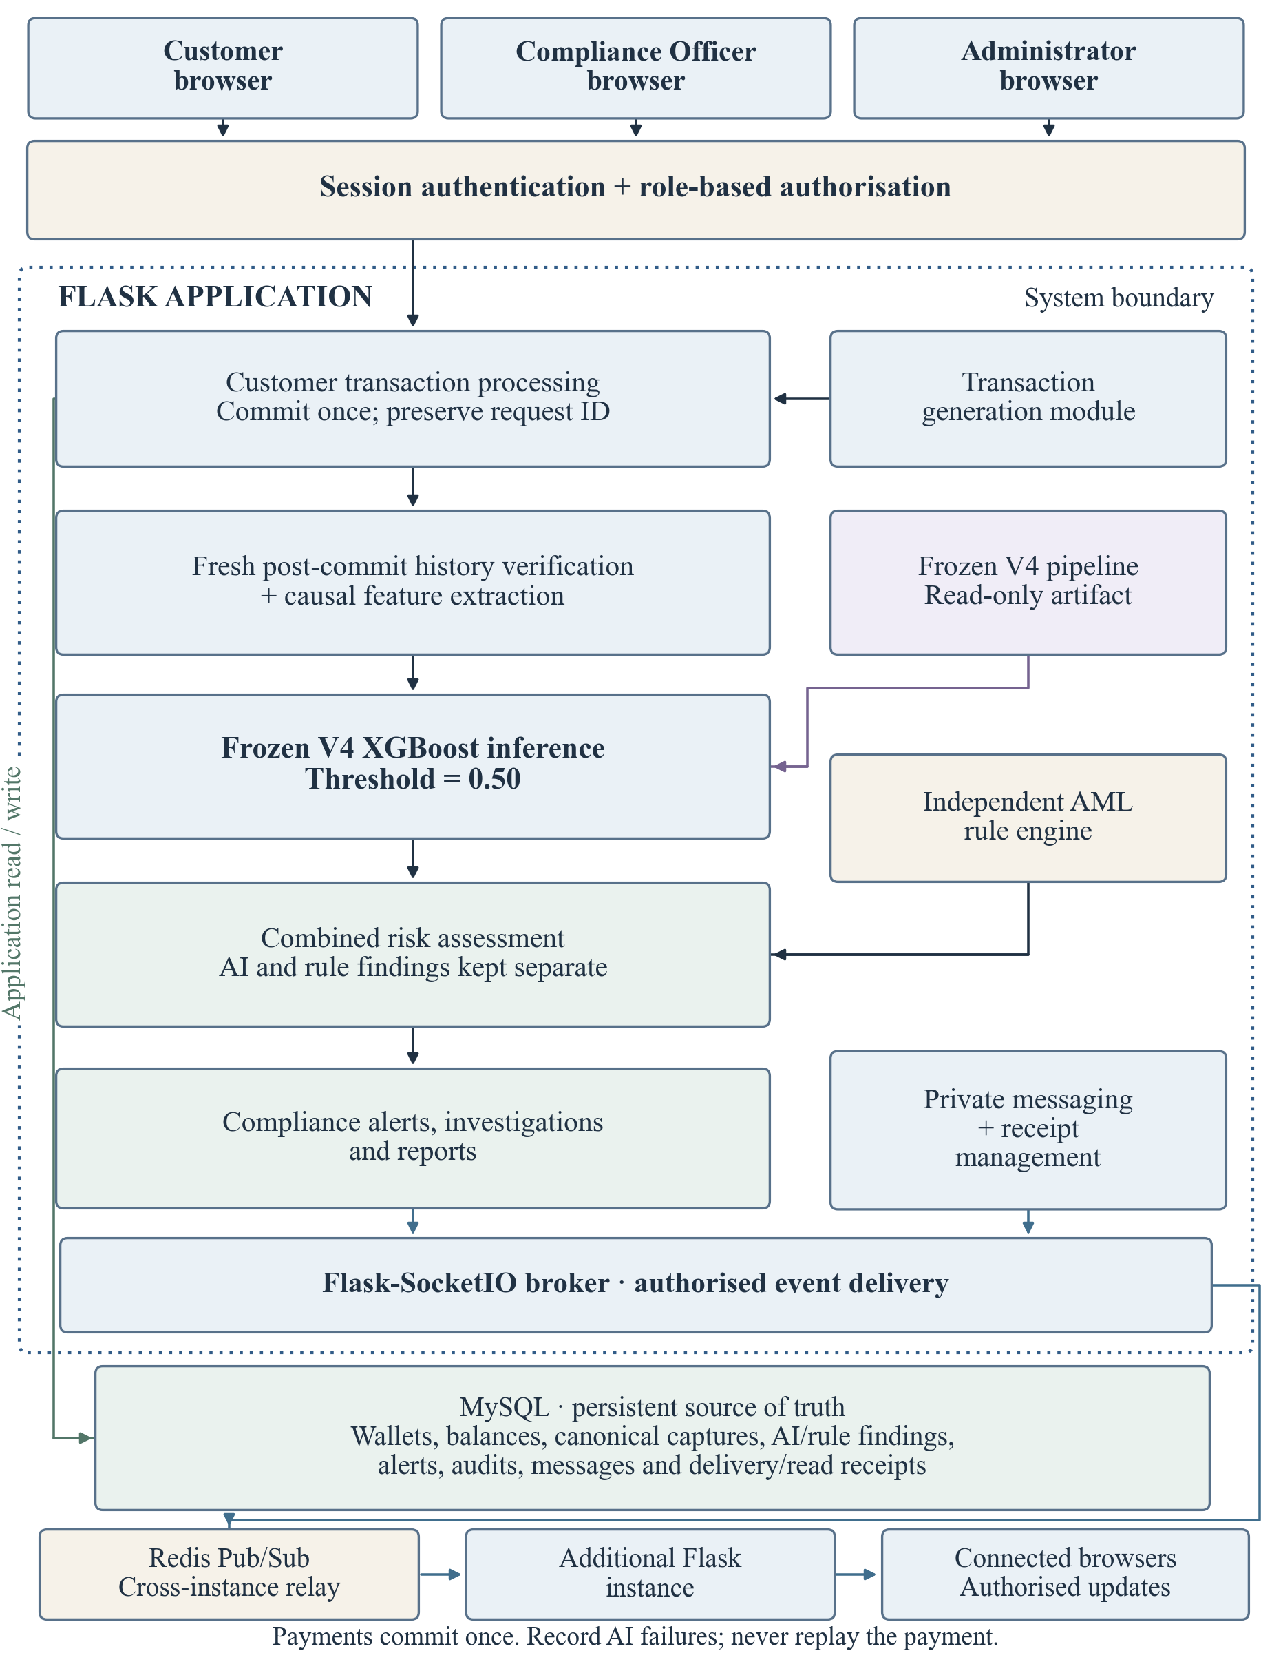
Figure 3.1: Application architecture

3.2.1 Hardware Requirements
Table 3.1 records the development workstation: Intel Core i5-9400H at 2.50 GHz, 16 GB RAM (15.73 GiB usable), a 475.86 GiB C: volume and Windows 11 x64 build 26300. These observed specifications are not measured minimum requirements or proof of identical hardware for historical fits. Tabular processing used the CPU without a dedicated GPU.
Table 3.1: Observed development hardware
Component | Verified specification | Role
Processor | Intel Core i5-9400H CPU at 2.50 GHz, x64 | Runs Flask, history construction and CPU inference
Physical memory | 16 GB installed; 15.73 GiB reported usable physical memory | Supports the application, database and local model processes
System storage | C: volume capacity 475.86 GiB | Stores application files, MySQL records and frozen model artifacts
Client access | Local HTTP/Socket.IO browser access; approved origin http://127.0.0.1:5000 | Local display and loopback access were used for interface observations; monitor dimensions and network-adapter throughput were not measured
Operating system | Windows 11 x64, build 26300 | Recorded local development environment; not a separate hardware minimum
The CPU handles requests, SQL coordination, causal aggregation and inference; RAM holds processes and intermediate arrays; storage retains the ledger and artifacts. Required capacity and latency also depend on history size, query efficiency and concurrency, so the recorded workstation does not establish deployment-wide performance.

3.2.2 Software Requirements
Python coordinates application and analytical services. Flask authenticates requests, checks roles and resource access, and returns HTML or JSON. MySQL atomically commits payment records, balance changes and canonical captures; unique client request IDs prevent repeated payments. Sessions identify accounts but do not replace wallet, alert or conversation authorisation.
The frozen scikit-learn-compatible pipeline preprocesses inputs before XGBoost combines successive trees into a suspicious-class probability [20]. NumPy provides arrays and joblib persists fitted artifacts. HTML, CSS, JavaScript and React provide the interfaces. Library compatibility is retained with the frozen artifact; installing a newer version alone does not establish compatibility.
Flask-SocketIO delivers events to authenticated rooms; Redis relays their envelopes across instances [17]. MySQL remains authoritative for financial history and message receipts. Publication therefore does not prove message delivery or reading. Device notifications additionally require browser permission and supported operating-system behaviour [18].
Table 3.2: Principal software components
Component and recorded version | Role and reproducibility boundary
Python 3.14.3 / Flask 3.1.3 | HTTP routes, sessions, role checks and payment coordination in the application virtual environment
MySQL 8.0.46 | Atomic financial records and persistent history, alerts, audits and messages
scikit-learn 1.9.0 / XGBoost 3.4.1 | Recorded candidate training and fitted preprocessing; retained classifier is XGBoost, not the predecessor Gradient Boosting model
NumPy 2.4.3 model runtime / 2.5.0 application | Distinct pinned numerical environments; frozen inference executes through the isolated model runtime
pandas 3.0.3 / joblib 1.5.3 | Tabular development processing; joblib persistence and trusted loading of the fitted pipeline
Flask-SocketIO 5.6.1 / Socket.IO JavaScript 4.7.5 | Python server extension and browser client, respectively; authenticated bidirectional events
Redis / redis-py 8.0.0 | Redis is the cross-instance relay; redis-py is its Python client package, not the server version
HTML, CSS, JavaScript and React | Browser layout, styling and interactive dashboards; installed browser and source declarations govern client compatibility
Browser Notifications API | Permission-controlled notifications from an open application page; not closed-browser Web Push

3.2.3 Software Operation and Component Interaction
HTTP requests carry validated user actions, while Socket.IO distributes committed changes without a full-page reload. The server, rather than the browser, assigns transaction identities, validates model inputs and enforces recipient permissions.
MySQL links payments, canonical captures, predictions, rules and alerts through transaction, user and wallet identities. The append-only retry audit records later analytical attempts without replacing the payment or introducing another ledger.
Redis is a transient relay: each Flask instance enforces its authenticated rooms, and reconnecting browsers reconcile stored state. Recipient acknowledgements, rather than broker publication, establish message delivery [17].
Figure 3.1 separates committed payments, post-commit V4 analysis, independent rules, combined assessment and authorised updates. The generator uses the supported payment path. The additional Flask instance depicts cross-instance operation without asserting that every observation used two running instances.

3.3 Transaction and History Process
The customer route validates identity, data, balance and request ID, then commits the payment, balances, independent rule evidence and canonical captures together. The existing verifier attests the new revision before V4 runs. Concurrent changes or analytical failures preserve the payment and permit only audited nonfinancial recovery (Figure 3.2).
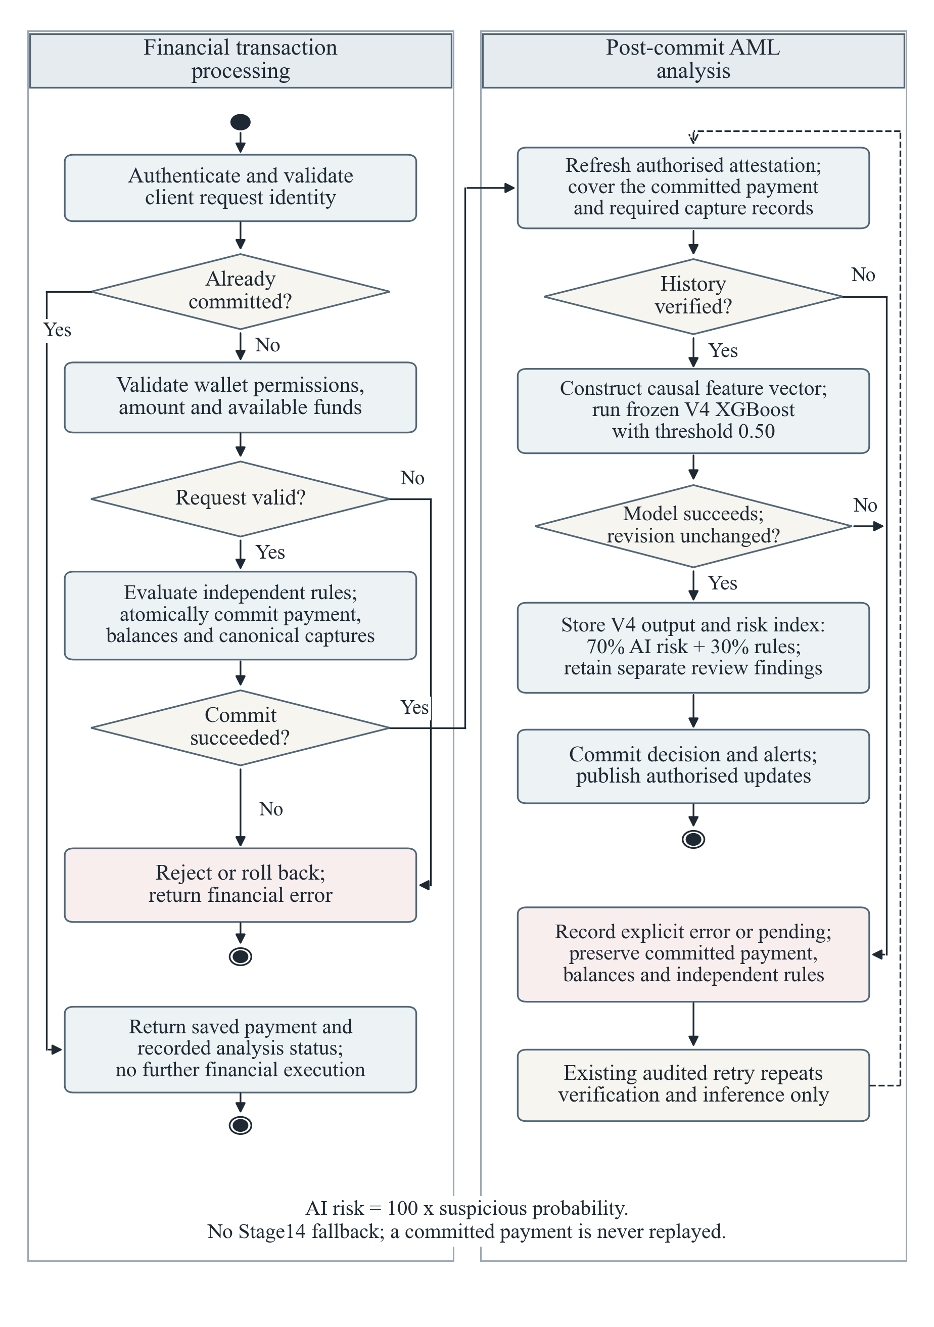
Figure 3.2: Post-commit transaction and AML activity

3.3.1 Algorithm 3.1: Committed Payment and V4 Risk Assessment
Algorithm 3.1 takes an authenticated payment request, unique client request ID, wallet records and authorised history. It returns one payment or validation failure, followed by a V4 assessment or explicit analytical error. The panel criterion is a completed assessment within thirty seconds of commit; this requires measurement.
1. Validate the authenticated role, transaction fields, requested wallet access and client request ID.
2. If the request ID already identifies a committed payment, return that payment and its stored analysis status without another debit or credit.
3. Check the relevant wallet balances, evaluate independent rules and save the payment, balance changes, rule evidence and required canonical captures in one database transaction. Roll back financial changes if this commit fails.
4. After a successful commit, refresh history attestation through the existing authorised verifier. Require coverage of the committed transaction and its capture records.
5. Construct the declared causal feature vector in its exact frozen order, run V4 inference and verify that the attested source revision remained consistent.
6. If verification or inference fails, preserve the payment and rules, record the specific analytical error or pending state and allow only the existing audited nonfinancial retry path.
7. Otherwise persist the V4 probability and fixed-threshold decision, calculate the numeric 70% AI-risk and 30% rule-risk index, retain independent review requirements and separate findings, update applicable alerts and publish authorised events after the decision commit.
Causal ordering uses normalised UTC time and integer transaction ID; prior events have smaller keys. Only declared fields include the current event once. Future events are excluded, and a concurrent source-revision change invalidates the assessment.
Post-commit persistence makes captures available without making the current payment its own prior history. The extractor adds it only to permitted fields; return paths, funding residuals, baselines and observed-age scalars remain prior-only.

3.3.2 Canonical History and Source Consistency
Every financial commit changes the canonical revision. The existing verifier must attest coverage of the new payment and required captures, and that revision must remain consistent through extraction and inference. A correctly shaped vector alone cannot establish source validity.
Source verification establishes completeness and revision integrity; causal extraction excludes information unavailable at assessment time. Scenario intentions, predictions and investigation outcomes remain interpretations, not observable transaction ground truth or estimator inputs.
Failed financial commits roll back. Completed payments with analytical failures retain their balances, IDs and rules while only verification and inference are retried. Reusing the request ID returns the existing payment.

3.4 Simulation and Preprocessing
The live simulator uses existing wallets for controlled cash-in, cash-out and transfers. Its 70% routine/30% suspicious mix describes scenario intentions, not accuracy or final alerts. Payments retain ordinary financial controls. Frozen V4 uses forty semantic fields expanded to forty-two estimator columns, causal thirty-five-day history and Train-fitted preprocessing [20].

3.4.1 Research Population and Partitioning
Completed development used 60,000 scored Train events plus 14,400 warm-up events, and 15,000 scored Validation events plus 3,600 warm-up events. Train contained 1,200 wallets and 96 agents across twelve communities; Validation contained 300 wallets and 24 agents across three disjoint communities. Warm-up supplied history without being scored. Entity isolation limits memorisation but does not establish operational generalisation.
Thirty-nine numeric fields and transaction type form the forty semantic inputs. Fixed wallet-to-wallet, cash-in and cash-out encoding yields forty-two estimator columns. Only declared missing markers are imputed; medians and scaling parameters are fitted on Train. Identity, scenario provenance and future events are excluded, and application inference requires the same exact order.
Table 3.3 distinguishes completed development from reserved evaluation designs. No accepted independent or real-operator V4 evaluation exists; predecessor metrics cannot substitute for V4 results.
Table 3.3: V4 development populations and reserved evaluation designs
Partition | Scored / warm-up events | Wallets / agents | Use and status
Train | 60,000 / 14,400 | 1,200 / 96 | Fitted preprocessing and candidate models
Validation | 15,000 / 3,600 | 300 / 24 | Compared candidates and reported development results
Final-test design | 15,000 / 3,600 | 300 / 24 | Reserved design; not an accepted V4 test result
Independent-evaluation design | 10,000 / 2,400 | 200 / 16 | Reserved design; no accepted independent V4 result
Train contained 47,770 target-zero and 12,230 target-one events; Validation contained 11,970 and 3,030 respectively, approximately twenty-percent positive prevalence. Targets are the union of twelve eligible observable predicates. Generation opportunities need not become positives, and overlapping family totals cannot be added as separate classes.
Each partition has separate entities, warm-up history and causal state, organised into communities of one hundred wallets and eight agents. This avoids shared-wallet leakage from a random row split, while retaining the limitations of a constructed network.

3.4.1.1 Frozen Research Generator and Reproducibility
The frozen research dataset, mobile_money_aml_synthetic_100k_v4, differs from live simulation. Its manifest identifies generator v4.generator.1.stage16r.1, predicate evaluator v4.predicates.1.stage16r.1 and temporal contract v4.temporal.1. Observable events contain transaction ID, UTC time, wallets, integer amount, currency, type, channel, agent, serviced wallet and flow direction. Targets and private provenance are diagnostic-only.
Reproducibility used master seed 2026092915. SHA-256 of the UTF-8 dataset identity, seed, partition and stream, separated by vertical bars, supplied its first sixteen bytes, interpreted as a little-endian unsigned integer, as the NumPy PCG64DXSM seed; /unit/<index> separated communities. Named streams isolated generation operations. The manifest retained code, specification and output hashes with Python 3.14.3/NumPy 2.4.3. Reserved streams additionally required a custodian secret.
Amounts were positive integer USD cents. Each proposal drew a 90%/10% lognormal mixture with medians USD 35/USD 1,800 and log standard deviation one, rejecting proposals outside USD 0.01–15,000. Recipe relations preceded half-up cent rounding. S4/H3 conditioned the same mixture on USD 5,000–13,000. Their inclusive USD 7,000–10,500 predicate band was synthetic, unrelated to legal thresholds or the 0.50 classifier threshold.
Each community allocated 5,000 scored opportunities: 2,000 background, 1,000 matched hard-origin and 2,000 family-origin. Largest-remainder allocation gave S2/S4/N3 weight two, other families weight one; H1–H8 had equal weights. Episodes uniformly used eight to twenty events within remaining budgets; smaller residuals became background. Motif ranges determined core events; remaining roles equally sampled baseline-compatible, unrelated, relationship-maintenance and post-motif context. Outcomes were never resampled to force target counts.
Background types were 50% wallet-to-wallet and 25% per cash direction. Of background transfers, 35% were agent-assisted with either serviced endpoint equally likely. Cash-in increased wallet balance/agent cash and reduced agent float; cash-out reversed these changes. Assisted transfers altered wallet balances and service history without agent inventories. Fixed opening inventories supported synthetic accounting, were excluded from inputs, and infeasible proposals stopped materialisation.

3.4.1.2 Scenario Recipes and Observable Target Conditions
Each family distinguishes a generation recipe from its observable target, requiring the applicable role, stated history and all listed conditions. Ineligible families are false; any other eligible family can still make the event positive. Target-zero therefore means no benchmark trigger, not verified legitimacy. Overlap is retained, without forced class or family counts.
S1: Variable fragment burst. Four to twelve events over five to sixty minutes divide a shared-law total by Dirichlet weights, allowing diffuse or dominant amounts. Matched H1 can favour a dominant payment.
Target: One-hour wallet activity has at least four events, two distinct cent amounts and USD 300 total; maximum value share is at most 60% and hourly-baseline acceleration at least three. Eligibility requires twenty-eight days plus one hour of observation and four baseline activities.
S2: Similar-amount repetition. Four to twelve payments over one to seven days perturb a shared-law anchor by lognormal jitter, with log standard deviation 0.01–0.15. H2 uses earlier recurring amounts where available; context can dilute the cluster.
Target: The inclusive ±5% current-centred seven-day cluster has at least four events, USD 200 and 60% of activities. Its count is at least twice baseline weekly-equivalent cluster count, denominator floored at one. Eligibility requires thirty-five-day observation and four baseline activities of any amount.
S3: Distributed same-day fragmentation. Six to sixteen events span three to twenty hours, using three to eight proposed hour positions with independent jitter. Midnight crossings need not become same-day positives.
Target: UTC-day activity through the current key reaches at least six events, three occupied hour buckets and USD 500. Count is at least twice the median of twenty-eight prior complete daily counts, including zeros and denominator floor one. Observation must cover that calendar boundary with four baseline activities.
S4: Variable near-threshold history. Five to twelve payments over one to seven days use the conditional large-amount distribution shared with H3, without origin-specific rounding, uniform sampling or positive-label rejection.
Target: Current amount is in-band; seven-day activity reaches at least five events, three in-band events, two distinct in-band cent amounts and 40% in-band share. Band count is at least twice the baseline weekly-equivalent count, denominator floor one. Eligibility requires thirty-five-day observation and four baseline activities.
N1: Many-to-one collection. Four to twelve incoming transfers from two to eight senders span one to twenty-four hours, retaining shared amounts and existing relationships. Matched H4 uses fewer senders.
Target: The receiver has at least four incoming transfers, three distinct senders and USD 300 in twenty-four hours, including the current edge. Acceleration over the preceding twenty-eight-day daily-equivalent rate is at least two. Eligibility requires twenty-nine-day observation and four prior incoming baseline edges.
N2: One-to-many dispersion. Four to twelve outgoing transfers reach two to eight recipients over one to twenty-four hours. Shared values and matched H5 separate intended origin from observable target.
Target: The sender has at least four outgoing transfers, three distinct recipients and USD 300 in twenty-four hours, including the current edge. Daily-equivalent acceleration is at least two, with twenty-nine-day observation and four outgoing baseline edges.
N3: Reciprocal relationship cycle. A two-to-six-vertex simple walk proposes a return, with zero to two competing-route edges over one hour to seven days. Reversed chronology and adjacent value factors 0.15–5 allow unsuccessful cycles.
Target: The current transfer closes any simple prior receiver-to-sender route of one to five edges in the open-lower seven-day horizon. Route keys increase strictly below the current key; vertices do not repeat. Adjacent prior value ratios are 0.25–4, and current/first-route value is 0.25–1.25. All eligible paths are searched, without a long-baseline requirement or selected-path shortcut.
N4: Wallet pass-through. An incoming transfer precedes mixed outward transfers/cash-outs over one to twenty-four hours. Two to twenty motif events propose outward fractions 0.1–1.2; context can add funding or other payments.
Target: For a transfer/cash-out, the earliest incoming transfer in the prior open-lower twenty-four hours anchors funding. Count incoming transfers/cash-ins from the anchor and outward transfers/cash-outs strictly after it, excluding current. Funding reaches at least USD 100; outward value including current is 50–100% of funding, and current does not exceed the prior residual. Cash-in alone cannot establish the anchor.
A1: Agent wallet growth. Eight to twenty services over two to twenty-eight days mix new and returning customers, using regular-catchment probability 0.2–0.9 and activity factor 0.8–2.5. H7 may reuse previously serviced wallets.
Target: Seven-day breadth reaches at least six wallets, including four absent from the prior twenty-eight-day baseline and a new-wallet share of at least 50%. Breadth is at least 1.5 times median weekly breadth in four preceding weeks. Eligibility requires thirty-five-day observation and twelve baseline services.
A2: Agent concentration. Eight to twenty services over two to twenty-four hours assign shares 0.35–0.90 to two to six regular wallets, while allowing other customers. H8 can reuse baseline-dominant customers.
Target: Twenty-four-hour activity reaches at least eight services; the two largest wallet counts represent at least 65% and exceed independently ranked baseline top-two share by at least 20 percentage points. Eligibility requires twenty-nine-day observation, twenty baseline services and five baseline wallets.
A3: Agent burst. Five to sixteen services to two to eight wallets span fifteen minutes to three hours, potentially crossing the one-hour target window. Matched H7 can have narrower breadth.
Target: One-hour activity reaches at least five services and three wallets, with acceleration at least three over the preceding twenty-eight-day hourly-equivalent rate. Eligibility requires twenty-eight days plus one hour of observation and twelve baseline services. Every service type counts; assisted transfers count once.
A4: Agent flow imbalance. Eight to twenty cash services over two to twenty-four hours involve two to eight wallets, cash-out probability 0.1–0.9 and direction-value multiplier 0.5–2. Matched H8 can have an already skewed baseline.
Target: Current is cash-in/out; twenty-four-hour cash activity reaches at least six events and three wallets. Absolute value skew is at least 0.6 and absolute count skew at least 0.5, with matching nonzero direction; value skew changes by at least 0.4 from baseline. Eligibility requires twenty-nine-day observation and twelve baseline services, including eight cash events. Transfers are excluded from cash sums.

3.4.1.3 Population Isolation and Reserved Evaluation
Partition identities are independent; unique positive sixty-three-bit transaction IDs are sampled without replacement and encode no family, time or partition. Each community has one hundred wallets/eight agents, with no cross-community endpoints, service, histories or state. Forty-two warm-up days precede 180 scored days, 12 February to 11 August 2027 exclusive; these dates are simulation coordinates.
The design totals 100,000 scored events, 24,000 warm-ups, 2,000 wallets and 160 agents. Completed Train/Validation development uses 75,000 scored events, 18,000 warm-ups, 1,500 wallets and 120 agents. Reserved final/independent designs failed public support checks and remained sealed, contributing no accepted V4 results (Figure 3.6).

3.4.2 Simulation Controls
The live generator validates a signed batch plan before writing. A ten-event mixed panel batch assigns seven routine and three suspicious intentions; these never become model labels. Each event retains a unique request identity and affects demonstration-wallet balances and canonical history, without resetting earlier records.
Existing and newly registered customer wallets participate. Per wallet, up to one hundred recent normal/low-risk outgoing transfers provide quartiles, median and five preferred recipients; fewer than five observations indicate limited history. Routine senders rotate across customers, although short batches cannot cover all. Current timestamps can trigger velocity rules even when amounts resemble prior behaviour.
After checking request identities, the generator locks and validates wallets/agents and commits the complete batch atomically. Failures roll it back. Reused signed tickets return complete stored receipts; incomplete prior receipts are refused. Post-commit analysis may remain pending without duplicating payments.

3.4.3 Data Preprocessing and Temporal Construction
Observable event fields supply accounting and join context. Private origin, family, campaign, onset and population annotations remain diagnostic-only and never enter estimator inputs, preventing scenario identifiers from revealing targets.
Each timestamp is normalised to UTC with microsecond precision and paired with its integer transaction ID. Events are processed in increasing key order. A prior event must satisfy $key\left(e\right) < key\left(T\right)$; smaller IDs resolve equal timestamps deterministically. The extractor emits features before updating historical state. Declared recent-window descriptors can include the current event exactly once, whereas prior routes and pre-event funding descriptors exclude it. Causal construction follows information available at assessment time, consistent with time-aware monitoring [15].
Recent windows have open lower boundaries; baselines precede them. State covers up to thirty-five days plus first-observation time. UTC-day features instead use the current partial calendar day against twenty-eight complete prior days, including zeros and excluding future current-day activity.
For the calculations, T is the current event; t its UTC time; a its integer-cent amount; k its timestamp/ID key; and H strictly prior events. Recent sets include T only for declared roles. Baselines exclude recent/current events. n counts events, V sums cents, W counts distinct serviced wallets and m denotes a median, including stated zero buckets.
$$R_{L} = \{e ∈ H : t - L < time(e) ≤ t\} ∪ \{T\}$$
$$B_{L} = \{e ∈ H : t - L - 28d < time(e) ≤ t - L\}$$
Wallet structuring activity counts sent transfers and cash services once; received transfers establish age/funding only. Agent activity uses the named serviced wallet, including assisted transfers. First participation is retained beyond state expiry: observation on the baseline lower boundary can establish age without entering its open-lower event count.
A historical gate requires the first prior observation at or before the relevant lower boundary and the stated baseline event count. G-S1 means twenty-eight days plus one hour and four wallet baseline activities; G-S3 means the start of the twenty-eight prior UTC days and four activities; G-N means twenty-nine days and four direction-specific wallet-transfer baseline edges; G-A1 means thirty-five days and twelve agent services; G-A2 means twenty-nine days, twenty services and five serviced wallets; G-A3 means twenty-eight days plus one hour and twelve services; G-A4 means twenty-nine days, twelve services and eight cash events. These are historical support gates, not complete suspicious-family triggers.
P contains simple chronological receiver-to-sender return routes of one to five prior edges in the open-lower seven-day horizon. Selection minimises maximum adjacent absolute log-value change, then length, then lexicographic edge keys, without current amount; a one-edge change is zero. For funding, the earliest incoming transfer within twenty-four hours anchors F (incoming transfers/cash-ins, anchor-inclusive) and O (later outward transfers/cash-outs), both prior-only.
Top-two share independently ranks wallet service counts in each window, dividing their two largest by all services; empty sets return zero. Cash-value/count skew is outward minus inward divided by their sum, with empty sets zero. These are observable summaries, not complete family triggers.
Missing-history handling is field-specific: genuine zeros remain zero; unsupported acceleration commonly uses -1 and change fields -3. Prior funding residual may legitimately be negative, including -1, so unavailable funding uses NaN. Universal replacement of negative values would erase valid observations.
Preprocessing validates exact semantic order, types and categories, rejects infinities, replaces declared sentinels and applies fixed type encoding, Train-fitted median imputation and scaling. Validation/inference use transform only, without missingness indicators, resampling, adaptive balancing or changes to stored money.
Table 3.4: Notation for causal feature calculations
Symbol | Meaning
T; t; a(e); k(e) | Current event; its UTC timestamp; positive integer amount of event e in cents; ordered UTC microsecond timestamp and integer ID pair
H; L; d | Strict-prior permitted history; recent duration; UTC midnight for the calendar exception
R-L; B-L | Recent role-specific window including T only where declared; preceding disjoint twenty-eight-day baseline
n(S); V(S); W(S) | Event count; integer-cent amount sum; distinct serviced-wallet set of event set S
m; Day(T); C-R; C-B | Median including declared empty bins; current UTC day through T; current-centred similar-amount recent/baseline sets
In-24h; Out-24h; B-in; B-out | Incoming edges of current receiver; outgoing edges of current sender; their respective directed baseline sets
P; p*; F; O | All eligible prior temporal return routes; route selected without current amount; prior observed anchored funding; prior anchored outward value
D; U; D1 to D4 | Recent agent distinct-wallet count; wallets absent from baseline; distinct-wallet counts in the four disjoint baseline weeks
top2; skew; CashIn; CashOut | Two largest serviced-wallet count share; signed cash-value skew; cash-in-only set; cash-out-only set
p; r; R; x41 to x44 | V4 positive probability; independent rule score; combined operational risk index; four diagnostic-only additional fields

3.4.4 Frozen Behavioural Feature Architecture
V4 retains forty semantic fields: two current-event, ten structuring, twelve network, fourteen agent and two coverage descriptors. Thirty-nine numeric fields plus three type indicators yield forty-two estimator columns. Tables 3.5–3.9 preserve frozen order and definitions.

3.4.4.1 Current-Event Context
Positive integer-cent amount supplies value context. One-hot transaction type avoids arbitrary ordering among wallet transfers and cash directions. Account IDs locate history but are not estimator features.
Table 3.5: Current-event fields and encoding
Order | Frozen field | Behaviour and window
1 | amount_minor | Transaction value context; current
2 | transaction_type | Current role and cash applicability; current
1. amount_minor. Current only. Positive integer cents; absent, nonnumeric, nonfinite or nonpositive values fail schema validation.
$$a = amount_minor(T)$$
2. transaction_type. Current only. Fixed encoding order: wallet_to_wallet, cash_in, cash_out. Unknown or absent categories are rejected.
$$type(T) ∈ \{W2W, Cash-In, Cash-Out\}$$

3.4.4.2 Structuring Features
Structuring descriptors measure bursts, similar amounts, UTC-day spread and historical change. Observable counts work at cold start; acceleration requires its baseline. The near-band range is synthetic rather than a statutory reporting threshold.
Table 3.6: Frozen structuring descriptors
Order | Frozen field | Behaviour and window
3 | wallet_count_1h | Short burst size; 1h
4 | wallet_value_1h | Short burst total value; 1h
5 | wallet_max_value_share_1h | Fragment dominance; 1h
6 | wallet_activity_acceleration_1h | Change from own background; 1h + preceding28d
7 | wallet_similar_amount_count_7d | Repeated similar payments; 7d
8 | wallet_similar_amount_share_7d | Repetition relative to all activity; 7d
9 | wallet_count_utc_day | Distributed daily activity; UTC day to current
10 | wallet_active_hours_utc_day | Temporal spread of daily activity; UTC day to current
11 | wallet_day_count_growth | Daily increase over own background; UTC day + prior28 calendar days
12 | wallet_near_band_count_7d | Large repeated payments near synthetic analytical threshold; 7d
3. wallet_count_1h. Wallet 1h activity, current once. No baseline gate; current ensures count at least one.
$$n(R_{1h})$$
4. wallet_value_1h. Wallet 1h activity, current once. Exact integer sum in cents; no baseline gate.
$$V(R_{1h})$$
5. wallet_max_value_share_1h. Wallet 1h activity, current once. Largest amount divided by positive recent value; larger values mean greater dominance.
$$\frac{max amount(R₁ₕ)}{V(R₁ₕ)}$$
6. wallet_activity_acceleration_1h. Wallet 1h recent + preceding disjoint 28d baseline. Current once in numerator; G-S1, otherwise -1. 672 is 28 days in hours.
$$\frac{n(R₁ₕ)}{max(1, \frac{n(B₁ₕ)}{672})}$$
7. wallet_similar_amount_count_7d. Wallet 7d activity, current once. C-R contains amounts within inclusive five percent of current cents; no rounding bins or baseline gate.
$$n(C_{R})$$
8. wallet_similar_amount_share_7d. Same cluster and 7d scope as field 7. Recent denominator counts every subject activity, not distinct amounts; it is positive.
$$\frac{n(Cᴿ)}{n(R₇d)}$$
9. wallet_count_utc_day. Wallet activity from UTC midnight through current key, current once. A calendar day, not rolling 24h; no gate.
$$n(Day(T))$$
10. wallet_active_hours_utc_day. Distinct occupied UTC hour buckets in field 9 activity, current once. Multiple payments in one hour occupy one bucket.
$$|occupied UTC hours in Day(T)|$$
11. wallet_day_count_growth. UTC day-to-current count versus median of 28 completed day counts, including zeros. G-S3, otherwise -1; current only in numerator.
$$\frac{n(Day(T))}{max(1, m(28 prior day counts))}$$
12. wallet_near_band_count_7d. Wallet 7d activity, current once. Inclusive integer-cent band USD 7,000 to USD 10,500; true zero is zero.
$$n(\{e ∈ R_{7d} : 700000 ≤ a(e) ≤ 1050000\})$$

3.4.4.3 Wallet and Transaction-Network Features
Network descriptors summarise directed counts, counterparties, acceleration, prior return routes and funding flow for the relevant sender/receiver. Prior connectivity selects paths before using current amount. These tabular summaries can lose graph information; V4 is not a graph neural network.
Table 3.7: Frozen network descriptors
Order | Frozen field | Behaviour and window
13 | network_in_count_24h | Volume; 24h
14 | network_in_distinct_24h | Counterparty breadth; 24h
15 | network_in_acceleration_24h | Change from own background; 24h + preceding28d
16 | network_out_count_24h | Volume; 24h
17 | network_out_distinct_24h | Counterparty breadth; 24h
18 | network_out_acceleration_24h | Change from own background; 24h + preceding28d
19 | prior_return_path_min_length_7d | Shortest temporal connectivity; prior7d
20 | prior_return_path_count_7d | Alternative paths omitted by a single shortest path; prior7d
21 | prior_path_min_max_log_change_7d | Prior value consistency over alternative paths; prior7d
22 | current_to_selected_path_first_value_ratio | Return value relative to selected prior route; prior7d + current
23 | wallet_pass_through_fraction_24h | Fraction of available recent funding transferred; anchor..current within 24h
24 | wallet_prior_funding_residual_minor_24h | Remaining observed funding before this outward event; anchor..current within 24h
13. network_in_count_24h. Incoming directed W2W edges of current receiver over 24h, current once. Repeated senders count as repeated events. Non-W2W: 0.
$$n(In_{24h})$$
14. network_in_distinct_24h. Distinct sending wallets in field 13 set. Repeated senders counted once. No baseline gate; non-W2W: 0.
$$|senders(In_{24h})|$$
15. network_in_acceleration_24h. Incoming current-receiver edges. Current once in recent numerator; G-N applies to incoming baseline, otherwise -1; non-W2W: -1.
$$\frac{n(In₂₄ₕ)}{max(1, \frac{n(B-in₂₄ₕ)}{28})}$$
16. network_out_count_24h. Outgoing directed W2W edges of current sender over 24h, current once. Repeated receivers remain repeated events. Non-W2W: 0.
$$n(Out_{24h})$$
17. network_out_distinct_24h. Distinct receiving wallets in field 16 set. Repeated receivers counted once. No baseline gate; non-W2W: 0.
$$|receivers(Out_{24h})|$$
18. network_out_acceleration_24h. Outgoing current-sender edges. Current once in recent numerator; direction-specific G-N, otherwise -1; non-W2W: -1.
$$\frac{n(Out₂₄ₕ)}{max(1, \frac{n(B-out₂₄ₕ)}{28})}$$
19. prior_return_path_min_length_7d. Prior 7d routes P, topology only; current endpoints select the query, current edge excluded. No path or non-W2W: -1.
$$min\{length(p) : p ∈ P\}$$
20. prior_return_path_count_7d. Prior 7d P, distinct full edge-key sequences; parallel edges remain distinct. No amount filtering or search truncation. No path/non-W2W: 0.
$$|P|$$
21. prior_path_min_max_log_change_7d. Selected prior route p*, ranked without current amount. One-edge route: 0; no path/non-W2W: -1. Natural logarithm.
$$max adjacent |ln(\frac{a-next}{a-previous})| on p*$$
22. current_to_selected_path_first_value_ratio. Current cents divided by first selected prior-route cents. Current amount is used only after route selection; no path/non-W2W: -1.
$$\frac{a(T)}{a(first edge of p*)}$$
23. wallet_pass_through_fraction_24h. Outward W2W or cash-out; prior anchor/funding within 24h and current amount once. No anchor or other current role: -1. Values are not clipped to one.
$$\frac{O + a(T)}{F}$$
24. wallet_prior_funding_residual_minor_24h. Same prior funding/anchor as field 23, current amount excluded. Missing anchor/non-outward: NaN; negative values, including -1, are valid observations.
$$F - O$$

3.4.4.4 Agent Features
Agent descriptors measure serviced-wallet breadth, concentration, acceleration and cash direction. Assisted transfers count one named service without moving agent inventory. Cash directions retain their roles; direct transfers use declared absent-agent values.
Table 3.8: Frozen agent descriptors
Order | Frozen field | Behaviour and window
25 | agent_wallet_growth_ratio_7d | Relative customer breadth growth; 7d + preceding28d
26 | agent_distinct_wallets_7d | Recent customer breadth; 7d
27 | agent_new_wallet_count_7d | New-to-baseline customer count; 7d + preceding28d
28 | agent_new_wallet_share_7d | Acquisition versus returning customers; 7d + preceding28d
29 | agent_top2_count_share_24h | Repeat-customer concentration; 24h
30 | agent_top2_share_change_24h | Concentration change; 24h + preceding28d
31 | agent_service_acceleration_1h | Short service burst relative to own activity; 1h + preceding28d
32 | agent_distinct_wallets_1h | Breadth within a short burst; 1h
33 | agent_cash_in_count_24h | Cash direction counts; 24h
34 | agent_cash_out_count_24h | Cash direction counts; 24h
35 | agent_cash_in_value_24h | Cash direction magnitude; 24h
36 | agent_cash_out_value_24h | Cash direction magnitude; 24h
37 | agent_cash_distinct_wallets_24h | Cash customer breadth; 24h
38 | agent_cash_value_skew_change | Cash directional change; 24h + preceding28d
25. agent_wallet_growth_ratio_7d. Agent 7d breadth D against four preceding disjoint weekly distinct counts including zero weeks. G-A1, otherwise -1; current service once.
$$\frac{D}{max(1, m(D₁,D₂,D₃,D₄))}$$
26. agent_distinct_wallets_7d. Agent 7d distinct serviced wallets, current service once. No baseline gate; absent agent: 0.
$$D = |W(R_{7d})|$$
27. agent_new_wallet_count_7d. Recent agent 7d wallets absent from entire preceding 28d baseline set. G-A1, otherwise -1; current service once. New is not globally newly registered.
$$U = |W(R_{7d}) ∖ W(B_{7d})|$$
28. agent_new_wallet_share_7d. Field 27 divided by field 26. Current service ensures D positive when an agent exists. G-A1, otherwise -1.
$$\frac{U}{D}$$
29. agent_top2_count_share_24h. Agent 24h two largest wallet event counts divided by all services, current once. Empty/absent agent: 0; independent top-two ranking.
$$top2(R_{24h})$$
30. agent_top2_share_change_24h. Difference of independently ranked recent 24h and baseline 28d top-two shares. G-A2, otherwise -3. Valid range -1 to 1; current recent service once.
$$top2(R_{24h}) - top2(B_{24h})$$
31. agent_service_acceleration_1h. Agent 1h count over preceding 28d hourly-equivalent rate, denominator floor one. G-A3, otherwise -1; current service once.
$$\frac{n(R₁ₕ)}{max(1, \frac{n(B₁ₕ)}{672})}$$
32. agent_distinct_wallets_1h. Agent 1h distinct serviced wallets, current once. No baseline gate; absent agent: 0.
$$|W(R_{1h})|$$
33. agent_cash_in_count_24h. Agent 24h cash-in service count; current included only when cash-in. Other service types do not enter this count; absent/none: 0.
$$n(CashIn_{24h})$$
34. agent_cash_out_count_24h. Agent 24h cash-out service count; current included only when cash-out. Absent/none: 0.
$$n(CashOut_{24h})$$
35. agent_cash_in_value_24h. Agent 24h cash-in amount sum in integer cents; applicable current cash-in once. Absent/none: 0.
$$V(CashIn_{24h})$$
36. agent_cash_out_value_24h. Agent 24h cash-out amount sum in integer cents; applicable current cash-out once. Absent/none: 0.
$$V(CashOut_{24h})$$
37. agent_cash_distinct_wallets_24h. Agent 24h distinct wallets serviced through cash only. Repeated wallets once; current cash service once. Absent/no cash: 0.
$$|W(Cash_{24h})|$$
38. agent_cash_value_skew_change. Recent cash-value skew less baseline cash-value skew. G-A4, otherwise -3; valid range -2 to 2. No current cash-role gate for this descriptor; current enters cash set only if cash.
$$skew(Cash_{24h}) - skew(B-cash_{24h})$$

3.4.4.5 Observed-History Coverage
Coverage measures observed participation age, capped at thirty-five days, rather than registration age. It identifies limited observable history without revealing private activation or predicate eligibility.
Table 3.9: Frozen observed-history context
Order | Frozen field | Behaviour and window
39 | wallet_observed_coverage_days | Observed history context; all prior; scalar first observation retained
40 | agent_observed_coverage_days | 35d coverage boundary is visible; all prior; scalar first observation retained
39. wallet_observed_coverage_days. Prior observed wallet participation age in elapsed days, capped at 35. Incoming transfers establish participation. No prior observation: 0; no private activation.
$$min(35, \frac{t - first prior wallet observation}{1 day})$$
40. agent_observed_coverage_days. Prior observed service age of current named agent, capped at 35. Absent agent or first service: 0. Current is excluded from first-prior lookup.
$$min(35, \frac{t - first prior agent service}{1 day})$$
Features can share observable components with benchmark predicates without representing complete trigger conjunctions or independently established criminal behaviour. Family membership is not a causal attribution of an individual prediction. V4 decisions and historical investigation context remain separately identified.
Exact amount similarity used an inclusive integer comparison, avoiding floating-point tolerance and near-equal rounding ambiguity:
$$C_{R} = \{e ∈ R_{7d} : 20|a(e) - a(T)| ≤ a(T)\}$$
The same similarity test can serve the S2 baseline target, but that baseline count is absent from retained V4. Labels, complete predicates, rules, alerts, predictions, IDs and absolute timestamps are excluded. Valid negatives remain intact, matrices must be finite after imputation, and original class prevalence is retained without resampling.

3.4.5 Algorithm 3.2: History-Aware Transaction Generation
Input: authorised administrator, customer wallets and balances, selected mode/count, signed batch identity and observed profiles.
BEGIN
VALIDATE administrator, count, batch signature and plan version.
READ all registered customer wallets and the supported existing history.
BUILD baselines from qualifying recent outgoing payments:
retain typical amounts, preferred recipients and limited-history status.
PLAN scenario intentions; use seven routine/three suspicious for ten.
ROTATE routine senders over the eligible customer population.
CHECK funds and bind each event to its unique client request ID.
COMMIT through the canonical financial path once.
RETURN saved IDs and balances; report AI completion separately.
END
Output: a reproducible plan and atomically saved batch; normal, suspicious, pending and error analysis counts remain measured outputs.
Panel acceptance criterion: ten valid payments saved within three minutes, with seven routine and three suspicious-scenario intentions, reconciled balances and no duplicate IDs. The elapsed time must be measured during the prepared demonstration; the limit is not a claimed observation.

3.5 Frozen Model and Risk Assessment
The primary artifact is frozen V4 XGBoost, SHA-256 555bf1606bf0af97361e3f187575b7229645d5979a43e4c812db259dbfd2bf18, with threshold 0.50. The archived thirty-feature/0.35 predecessor is not an active fallback. Independent rules remain enabled and separately attributable. Model, preprocessing and threshold stay fixed throughout development reporting and application use.
For newly completed V4 decisions, the numeric operational risk index is defined as:
$$R = round\left(0.70 × \left(100p\right) + 0.30r, 2\right)$$
Here p is suspicious-class probability and r the independent rule score (0–100). The numeric policy gives AI 70% weight and rules 30%, without changing the classifier or threshold. It uses suspicious probability, not confidence in the selected class.
Review level is determined separately: it retains the most severe of the weighted-score band, independent rule band and a minimum suspicious review requirement for a positive V4 prediction. Consequently, a transaction with $p = 0.20$ and rule score 40 has a numeric score of 26.00 but still requires suspicious review because of its independent rule finding. A transaction with $p = 0.50$ and no rule finding has score 35.00 and also requires suspicious review because V4 is positive. These illustrative calculations demonstrate the policy and are not reported live payments.
Unresolved V4 remains explicitly pending/error with rule-only evidence and no substituted prediction. Primary/retry assessments use the same policy, preserving alert identity, status, assignment and notes. Earlier finalised scores are not silently rewritten.
Personal amount deviation is an independent V4-path rule. It uses up to one hundred prior completed same-sender/type payments within thirty days, causally ordered, and requires five observations. Its bounds are:
$$U = max\left(3m, μ + 3σ\right)$$
$$L = max\left(0, min\left(\frac{m}{3}, μ - 3σ\right)\right)$$
Here m is the sample median, μ the mean and σ the population standard deviation. A strict breach creates a separate forty-point rule with baseline evidence. This sample differs from the generator’s normal/low-risk transfer profile.

3.5.1 Candidate Comparison and Freeze
Logistic Regression, Random Forest, HistGradientBoosting and XGBoost were compared at fixed threshold 0.50. Eligible candidates were ranked by macro F1; within 0.005 of the best, lower false-positive rate took priority. This selected XGBoost over HistGradientBoosting despite lower positive recall. The selected pipeline was frozen, without application-driven tuning.
Logistic Regression supplies a linear baseline; Random Forest averages nonlinear trees; HistGradientBoosting and XGBoost sequentially reduce loss. Identical partitions and preprocessing support a controlled comparison. Depth, shrinkage and regularisation constrain XGBoost complexity [20].
Selection was fixed before comparison. Eligibility required $F_{1, macro} ≥ 0.80$, ${Recall}_{suspicious} ≥ 0.65$, $FPR ≤ 0.10$, the declared domain and reference-family gates, acceptable negative-origin slices, limited Train–Validation macro-F1 difference and seed-repeat stability. Eligible models were ranked by macro F1; those within 0.005 of the best were compared by false-positive rate, minimum domain recall, fit duration and lexical identifier. These synthetic tolerances do not establish regulatory certification or waive sparse family support.
All candidates used seed 2026092915, Train-fitted median imputation/scaling and natural rows without class weighting. Declared configurations below used no adaptive grid search, Validation early stopping or Validation-fitted transformations.
Logistic Regression: lbfgs solver, C 1.0, L2 regularisation convention, fit_intercept true, max_iter 2,000 and tolerance 0.0001; no warm start.
Random Forest: 160 trees, Gini impurity, unrestricted depth, square-root feature subsampling, minimum leaf size two, minimum split size two, bootstrap sampling true and one worker; no out-of-bag selection.
HistGradientBoosting: log-loss objective, 200 iterations, learning rate 0.07, 31 maximum leaf nodes, minimum leaf size twenty, L2 regularisation one, 255 bins, no maximum depth and early_stopping false; full feature fraction.
XGBoost: binary logistic objective, 200 trees, maximum depth five, learning rate 0.07, minimum child weight five, L2 regularisation one, row and tree-column fractions one, histogram construction and one worker; no early stopping.
Version-pinned defaults and full parameter dictionaries are retained in the training plan. Sixteen fits comprised four selectable primary models, four dominant-feature-removal fits, four seed-plus-one repeats and four diagnostic fits (dominant-only, missingness-only, tiny-feature and shuffled-label). The thirty-six-fit budget left twenty unused slots. Only primary models were selectable; threshold search was excluded.
Eligibility required macro F1 at least 0.80, positive recall at least 0.65 and FPR at most 0.10; domain and S3/N2/A1 recall at least 0.60; hard-origin FPR at most 0.20 with at least one hundred negative observations; Train-minus-Validation macro-F1 gap at most 0.08; absolute seed-repeat change at most 0.03; and no unresolved technical failure or warning. These synthetic gates do not certify sparse families or regulatory compliance.
Probability extraction checks the stored positive class label one; the frozen [0,1] pipeline returns it in column one. This is not calibrated criminal-conduct probability. Input requires forty ordered semantic fields and forty-two finite transformed columns; wrong names, dimensions, categories or metadata fail explicitly. Only permitted missing markers enter imputation.
Suspicious probability and classification are distinct. If p denotes model output:
$$prediction = \left\{\begin{aligned}1, if p ≥ 0.50 \\ 0, otherwise\end{aligned}\right.$$
V4 classification is separate from application risk and independent rules [6]. An unresolved assessment is not a zero probability or a rule relabelled as an AI prediction.

3.5.2 Post-Commit Failure Handling
After financial commit, verification, extraction and inference must share a stable revision. Failure preserves the payment and rules and records pending/error state; only audited nonfinancial work may be retried. This preserves financial finality and analytical traceability.
Numeric bands are normal below 25, low from 25, suspicious from 40, high from 60 and critical from 80. Review retains the highest weighted/rule band and a suspicious floor for positive V4. Suspicious-or-higher review creates an alert even below weighted score 40. Unresolved V4 retains rule-based review at rule score at least 40; otherwise analysis remains pending. Internal flags are not external regulatory submissions.
Alerts retain separate AI/rule origins. Low-risk decisions without review requirements need no suspicious alert. Notes, assignments, outcomes and escalations remain human case records, never inputs to reconstruct prior probabilities. Committed changes reach authorised staff; customers receive only their permitted transaction state.

3.5.3 History-Aware Transaction Generation
Section 3.4.2 defines the live generator’s customer coverage, historical sample and atomic batch controls. Previously simulated payments may form part of observed profiles; those profiles describe history rather than establish legitimacy. Suspicious intentions and the 70/30 scenario mix never determine V4 outcomes.

3.5.4 Model Configuration
Table 3.10 records the frozen XGBoost configuration. The binary:logistic objective supplies suspicious probability; the separate 0.50 threshold determines classification. Fixed type encoding expands forty semantic fields to forty-two columns.
Table 3.10: Frozen V4 XGBoost configuration
Parameter | Recorded value
Objective / evaluation metric | binary:logistic / logloss
Estimators / maximum depth | 200 / 5
Learning rate / minimum child weight | 0.07 / 5
L2 regularisation | reg_lambda = 1
Row / tree-column subsampling | subsample = 1; colsample_bytree = 1
Tree construction / worker count | hist / 1
Random seed | 2026092915
Semantic / estimator input dimensions | 40 / 42
Suspicious-pattern decision threshold | 0.50, using $probability ≥ threshold$
The recorded training plan and model card supply these settings. Runtime integrity checks use the hash in Section 3.5 and load existing fitted preprocessing; this description neither refits nor changes the artifact.

3.5.5 Completed Training and Validation Procedure
Each partition was validated and extracted independently from its own causal history. Warm-up supplied context without becoming scored outcomes. Independent benchmark predicates supplied targets, rather than application rules or live scenario proportions.
Train alone fitted missing-value imputation and scaling, preserving valid negative values and using the declared empty-column zero. Validation reused the fitted transformations. No resampling, class weighting, adaptive threshold search, early stopping, probability calibration or Train-plus-Validation refit was applied.
The fixed eligibility policy compared all four candidates through precision, recall, macro F1, FPR, confusion counts, ROC-AUC, average precision and family diagnostics. Chapter 4 reports the synthetic development results; they do not constitute independent or operational evaluation.

3.5.6 Recorded Pipeline Construction
Listing 3.1 documents retained offline construction with frozen names and missing markers. Its fit/prediction calls were not executed for this revision. The Flask route loads the trusted fitted artifact and only transforms inputs and predicts probabilities.
Listing 3.1: Retained full-mode preprocessing and classifier construction
import numpy as np
import xgboost
from sklearn.pipeline import Pipeline
from sklearn.impute import SimpleImputer
from sklearn.preprocessing import StandardScaler
from sklearn.base import BaseEstimator, TransformerMixin

CATEGORIES = ('wallet_to_wallet', 'cash_in', 'cash_out')

class FrozenPreprocessor(BaseEstimator, TransformerMixin):
def __init__(self, names, markers):
self.names, self.markers = names, markers

def raw(self, x):
if x.dtype.names != tuple(self.names):
raise ValueError('Frozen semantic order mismatch')
if not np.isin(x['transaction_type'], CATEGORIES).all():
raise ValueError('Unknown transaction type')
arrays, columns = [], []
for name in self.names:
if name == 'transaction_type':
for category in CATEGORIES:
arrays.append((x[name] == category).astype(float))
columns.append(name + '=' + category)
else:
value = x[name].copy()
marker = self.markers.get(name)
if marker is not None:
value[value == marker] = np.nan
if np.isinf(value).any():
raise ValueError('Infinite input')
arrays.append(value)
columns.append(name)
return np.column_stack(arrays), columns

def fit(self, x, y=None):
values, self.output_columns_ = self.raw(x)
self.imputer_ = SimpleImputer(
strategy='median', keep_empty_features=True,
add_indicator=False)
values = self.imputer_.fit_transform(values)
self.scaler_ = StandardScaler().fit(values)
self.n_train_rows_ = len(x)
return self

def transform(self, x):
values, columns = self.raw(x)
if columns != self.output_columns_:
raise ValueError('Column mismatch')
return self.scaler_.transform(
self.imputer_.transform(values))

from pathlib import Path
import json

# Resolve these paths from the application project directory.
spec = json.loads(Path(
'ml_v4/design/v4_feature_spec.json').read_text())
names = tuple(field['name'] for field in spec['features'])
markers = {
field['name']: (
-1 if field['missing_semantics'].startswith('-1') else -3)
for field in spec['features']
if field['missing_semantics'].startswith(('-1', '-3'))}
folder = Path('ml_v4/development_features/matrices')
X_train = np.load(folder / 'train/X.npy', allow_pickle=False)
y_train = np.load(folder / 'train/y.npy', allow_pickle=False)
X_validation = np.load(
folder / 'validation/X.npy', allow_pickle=False)
classifier = xgboost.XGBClassifier(
n_estimators=200, max_depth=5, learning_rate=0.07,
min_child_weight=5, subsample=1, colsample_bytree=1,
reg_lambda=1, tree_method='hist', n_jobs=1,
random_state=2026092915, eval_metric='logloss')
pipeline = Pipeline([
('preprocess', FrozenPreprocessor(names, markers)),
('model', classifier)])

# Completed offline procedure, shown for reproducibility:
pipeline.fit(X_train, y_train)
probability = pipeline.predict_proba(X_validation)[:, 1]
prediction = (probability >= 0.50).astype(np.uint8)
The listing reproduces full-mode construction. Original diagnostic-only feature-drop/restricted modes are not application inference paths. The hash-identified fitted pipeline remains authoritative.

3.5.7 Algorithm 3.3: Compliance Review and Outcome Recording
Input: authenticated officer, permitted alert ID, payment/history, V4 result, independent rules and investigation form.
BEGIN
AUTHORISE officer and requested alert before returning details.
LOAD payment, history, V4 result and independent rules.
DISPLAY score and separately named AI/rule reasons.
IF V4 is pending or failed THEN show its recorded state.
ACCEPT a supported assignment, note or investigation outcome.
VALIDATE and persist the action with its audit identity.
PUBLISH the committed update to authorised staff.
END
Output: a retained investigation action; payment, model result and human outcome remain distinct.
Panel acceptance criterion: one flagged transaction reviewed and an outcome recorded within two minutes, with separate AI and rule findings. The elapsed time must be measured during the prepared demonstration; the limit is not a claimed observation.
Officers can assign, annotate, resolve or escalate alerts. Outcomes preserve their evidence separately without editing model probabilities. Internal case records do not imply automated external submission.

3.6 Messaging and Notification Process
Messaging stores content before private Socket.IO notification. Contact policy permits customer–customer, customer–compliance and compliance–administrator conversations, blocking customer–administrator. Sent means committed; delivered requires recipient acknowledgement; read requires a visible open thread. Cursor pagination restores history. Device notifications require permission and an open application tab (Figure 3.3).
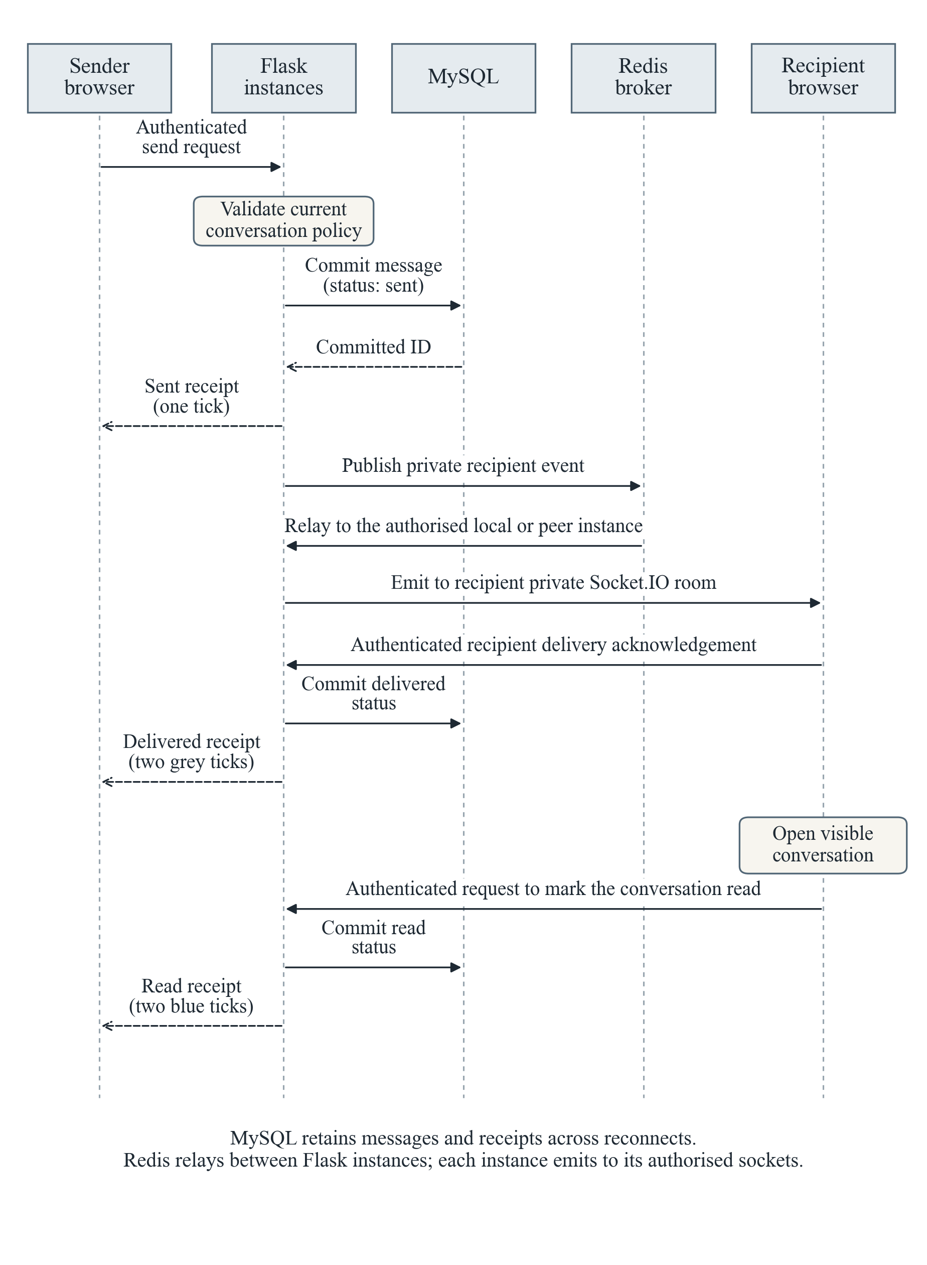
Figure 3.3: Authenticated message and receipt sequence

3.6.1 Access, Persistence and Privacy
Contact, history, attachment and receipt requests enforce authenticated participation and current conversation permissions. The server ignores unauthorised supplied recipients and rejects unrelated delivery acknowledgements. Private rooms preserve isolation across Redis-connected instances; reconnecting browsers retrieve persisted messages and statuses.

3.6.2 Event and Receipt Semantics
Algorithm 3.4 publishes committed events through Redis to the matching authenticated room on each instance. Reconnecting clients read stored state. The panel criterion is an authorised second-instance update within five seconds, with unrelated clients excluded.
Algorithm 3.5 persists message and receipt transitions before notification: one sent tick, two grey delivered ticks and two blue read ticks. Its criterion is a stored message/reply and receipts within two minutes per required conversation pair.

3.6.3 Algorithm 3.4: Authorised Cross-Instance Event Delivery
Input: committed event, authorised audience, Redis-backed broker and authenticated Socket.IO rooms.
BEGIN
WAIT until underlying database state has committed.
CREATE an envelope for the permitted destination audience.
PUBLISH through the configured Redis-backed broker.
ON each instance, route only to the matching room.
UPDATE the permitted browser from the event or current-state read.
ON reconnect, reconcile stored state; never invent receipts.
END
Output: the same committed update reaches the authorised second-instance browser; unrelated rooms receive no private event.
Panel acceptance criterion: an authorised transaction or alert update displayed across two instances within five seconds, excluding unauthorised access. The elapsed time must be measured during the prepared demonstration; the limit is not a claimed observation.

3.6.4 Algorithm 3.5: Persistent Message and Receipt Processing
Input: authenticated participants, current permission, content, optional permitted attachment and thread cursor.
BEGIN
VALIDATE conversation policy, participants and message data.
COMMIT message and persistent ID before emitting an event.
RETURN sent status; notify the recipient private room.
IF the authenticated recipient browser acknowledges receipt THEN
persist delivered status and notify the sender.
IF the recipient opens the visible conversation THEN
persist read status and notify the sender.
REJECT unrelated acknowledgements; retrieve history on reconnect.
END
Output: retained history with one sent tick, two grey delivered ticks and two blue read ticks; publication alone does not establish delivery.
Panel acceptance criterion: a persisted message/reply with receipt transitions within two minutes for each required customer–compliance and compliance–administrator pair. The elapsed time must be measured during the prepared demonstration; the limit is not a claimed observation.

3.6.5 Supporting Process and Model Diagrams
Figures 3.4 and 3.5 detail the generation and frozen inference processes described in Sections 3.4.5 and 3.5.6.
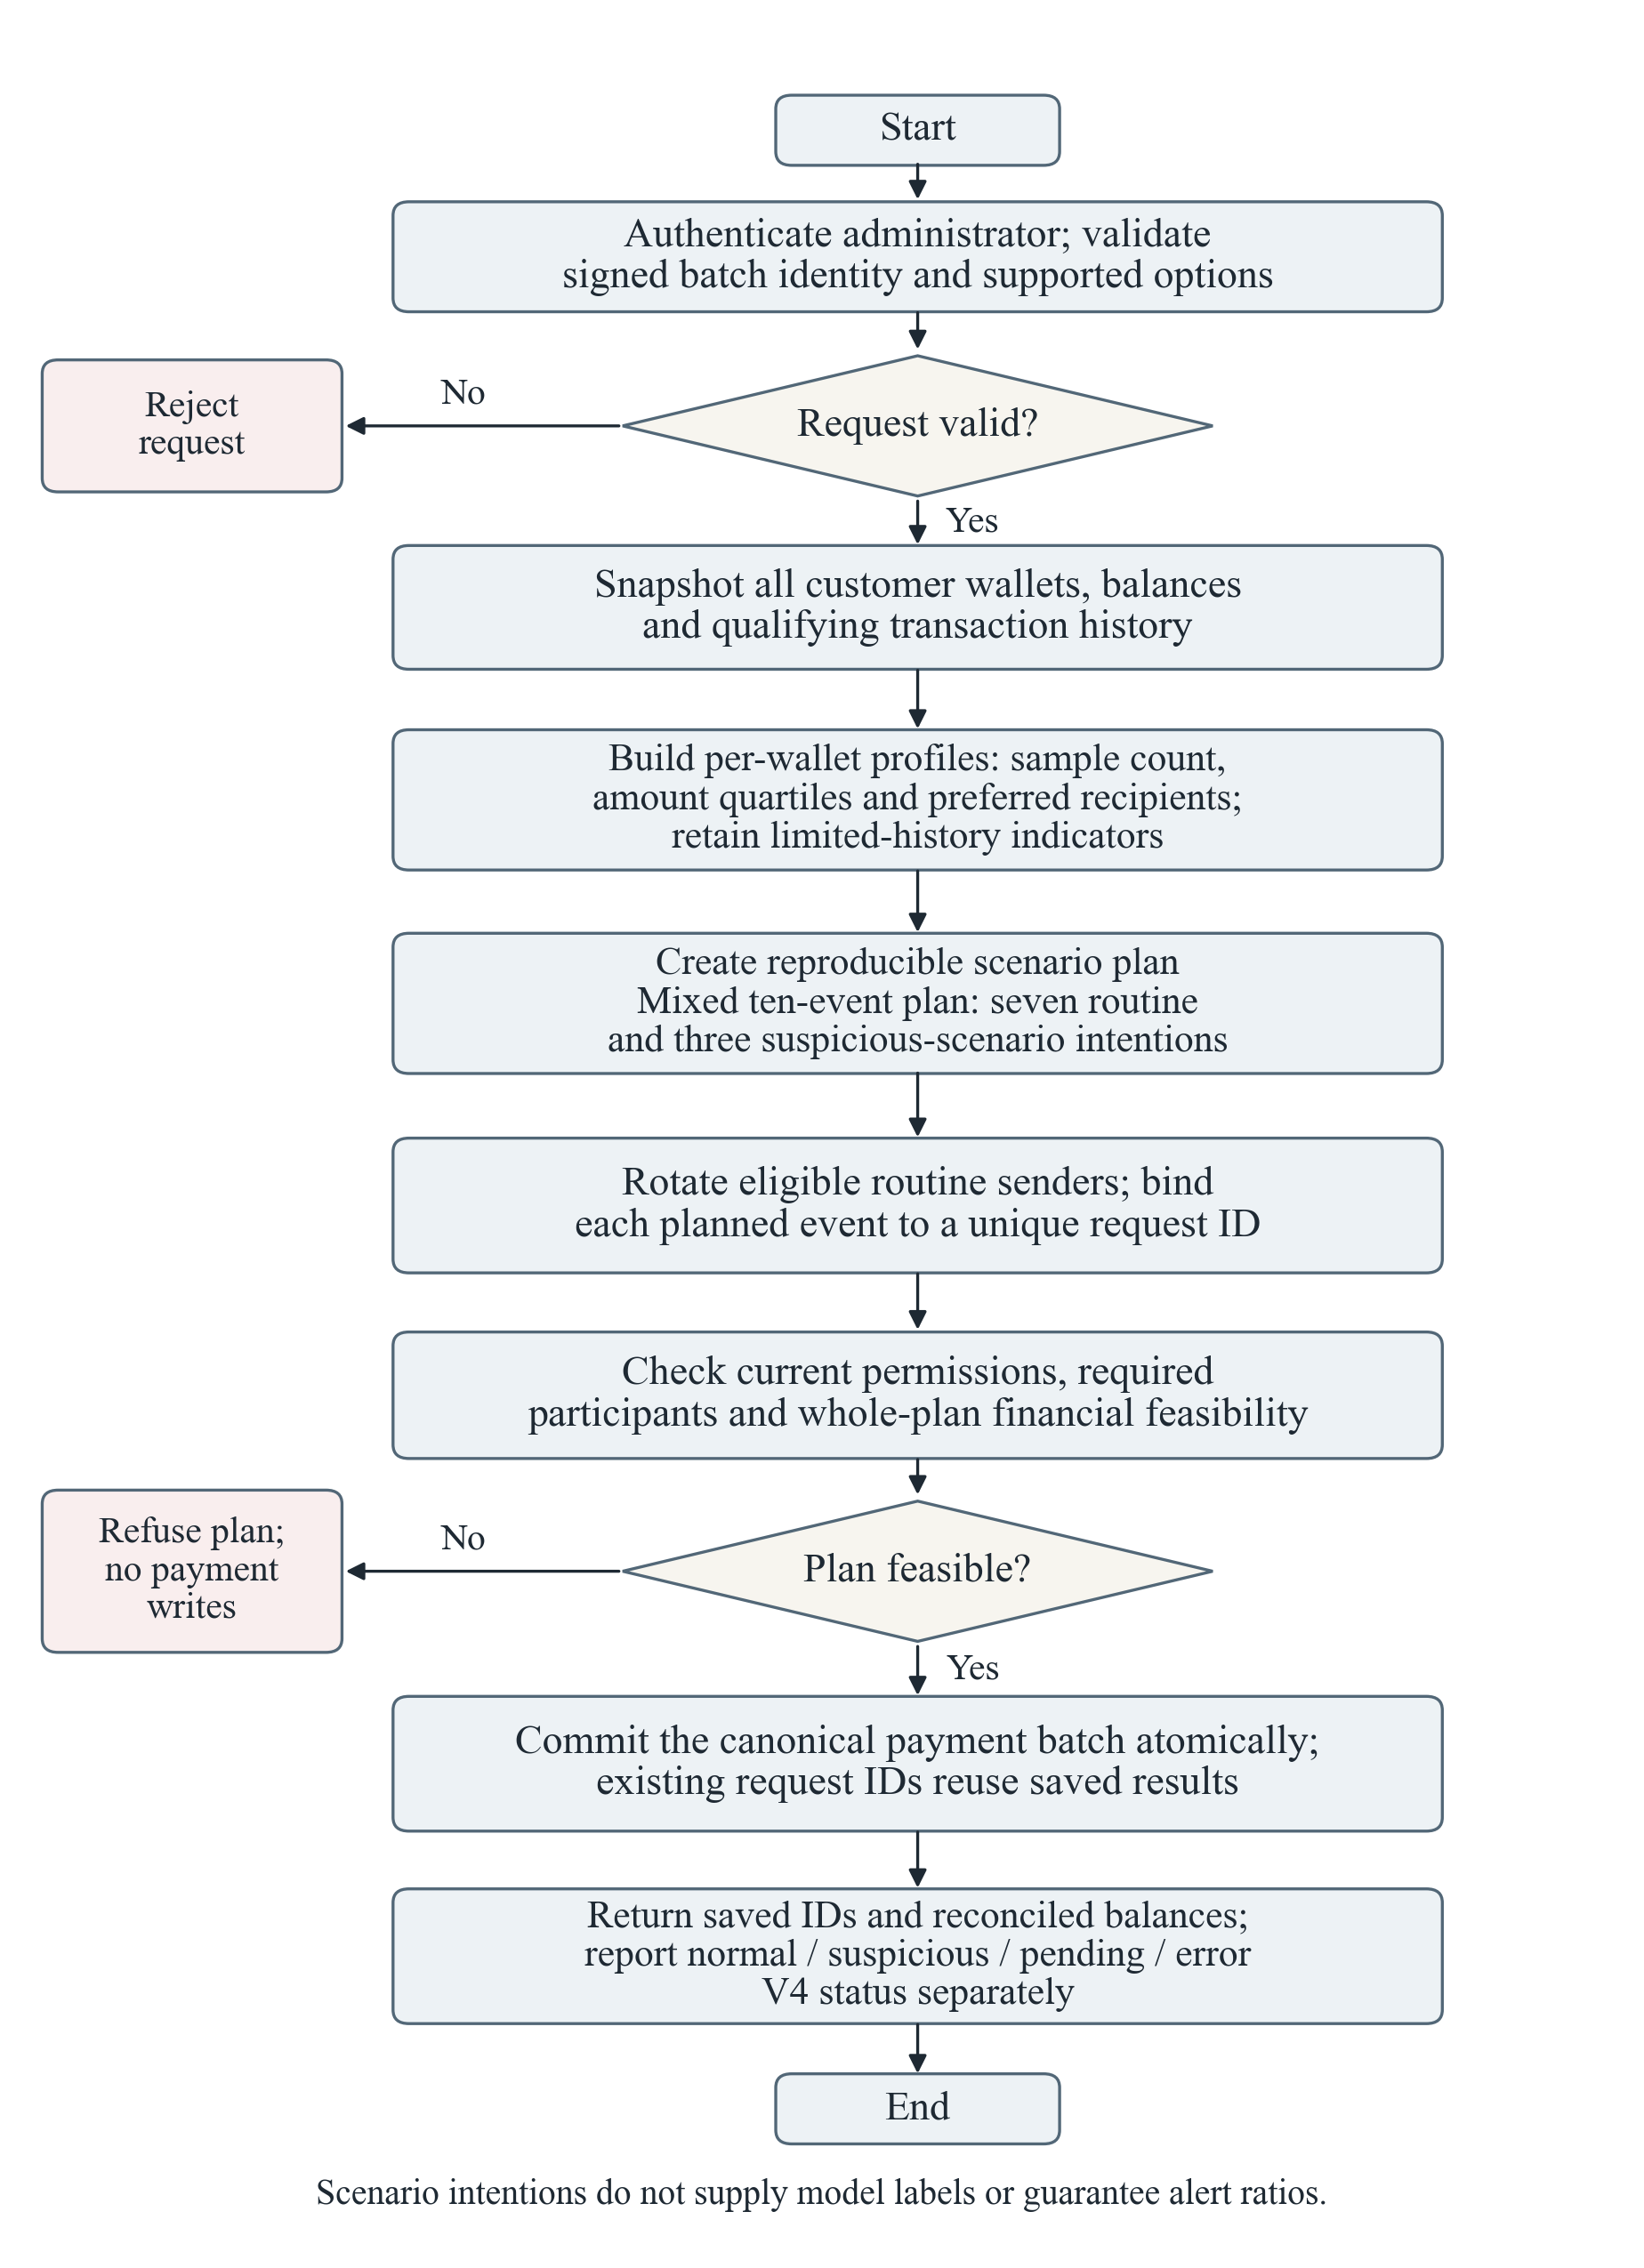
Figure 3.4: History-aware transaction generation flowchart
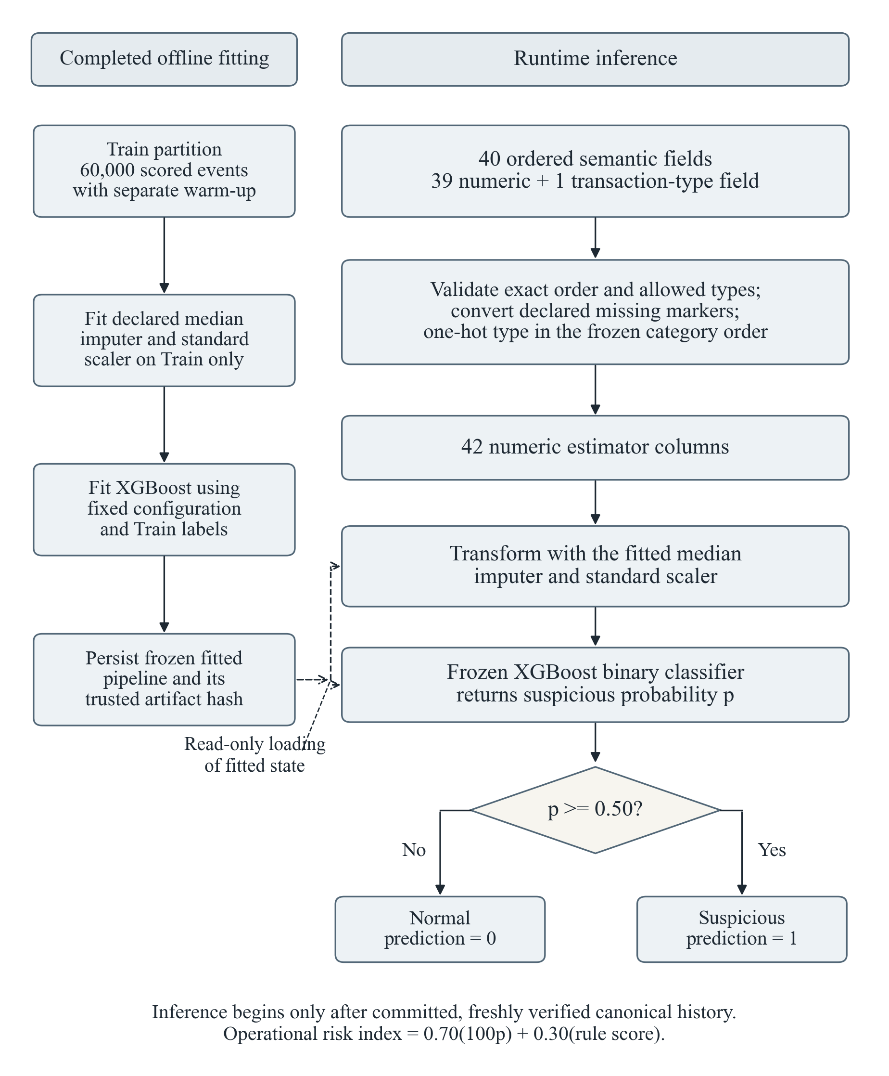
Figure 3.5: Frozen V4 preprocessing and inference pipeline
Figure 3.6 separates research generation from live simulation. Labels/features consume the same observable stream independently; private provenance remains diagnostic-only. Reserved populations indicate intended evaluation, not accepted results.
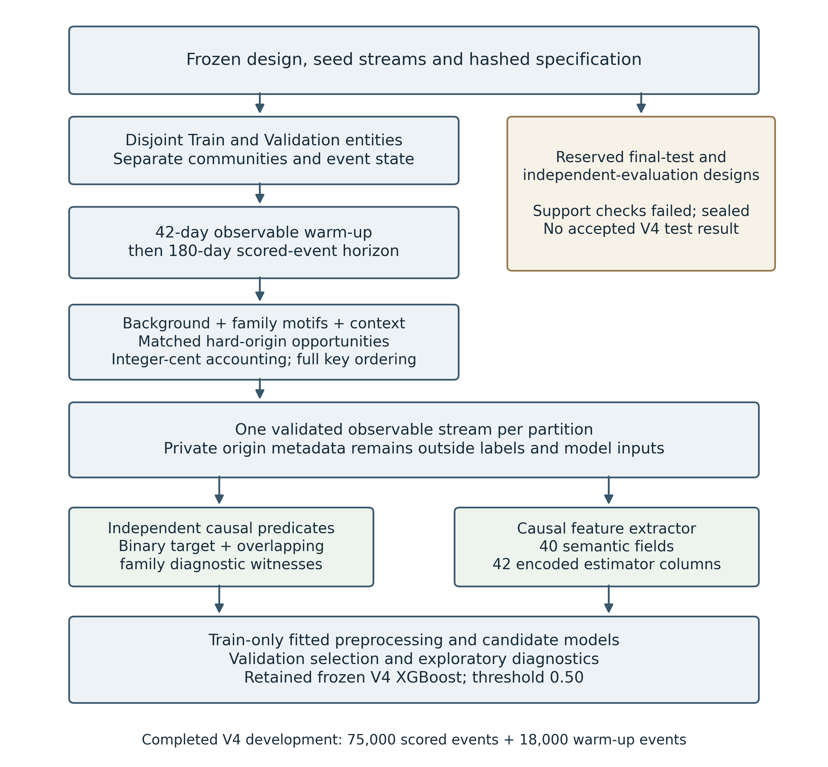
Figure 3.6: Frozen research-data construction and authorised V4 development boundary

3.7 Verification Method
Verification checked artifact identity, feature order/threshold, history authority, roles, duplicate prevention and separate evidence. Controlled browser fixtures exercised pages and receipts; read-only page checks fingerprinted protected tables before/after. Statistical results came from recorded synthetic Validation only.

3.7.1 SMART Demonstration Measurements
Table 3.11 translates the unchanged Chapter 1 objectives into observable tests. Prepared authenticated workflows are timed to the stated outcome and linked to stored transaction/message IDs. Late or pending outcomes remain unachieved measurements; development deadlines do not establish execution performance.
Table 3.11: Demonstrable workflow acceptance criteria
Objective / process | Timed observable outcome | Acceptance limit
1. Transaction generation module | Ten saved valid events: seven routine and three suspicious-scenario intentions; unique identities and balance reconciliation | 3 minutes
2. Redis and WebSocket real-time engine | Authorised event displayed on a second instance; unauthorised access excluded | 5 seconds
3. Compliance dashboard | Flagged transaction reviewed with separate AI/rule findings and an investigation outcome recorded | 2 minutes
4. Trained-model and rule risk assessment | One committed payment displays a completed combined assessment with separately identified component findings | 30 seconds
5. Professional messaging | One persisted message and reply with sent, delivered and read receipts for each required authorised pair | 2 minutes per pair
Controlled transfers reconcile equal sender debit/recipient credit, while repeating the same request ID must create no additional payment. Disposable stores and mocks test failures without live payments. These checks measure financial integrity rather than detection accuracy.

3.7.2 Recorded Training and Validation Performance
Accuracy measures correct classifications; log loss penalises erroneous probabilities, especially confident errors. Macro F1 weights both classes equally; suspicious recall measures positive detection, and FPR measures negative misclassification. Their combination avoids relying on overall accuracy alone [3].
Table 3.12: Recorded candidate Train and Validation accuracy and loss
Candidate | Train accuracy | Train log loss | Validation accuracy | Validation log loss
Logistic Regression | 0.8852 | 0.2804 | 0.8903 | 0.2714
Random Forest | 0.9964 | 0.0492 | 0.9661 | 0.1009
HistGradientBoosting | 0.9820 | 0.0508 | 0.9755 | 0.0636
V4 XGBoost | 0.9754 | 0.0671 | 0.9727 | 0.0731

Table 3.13: Candidate Validation measures used in selection
Candidate | Macro F1 | Suspicious recall | False-positive rate
Logistic Regression | 0.8105 | 0.5977 | 0.0357
Random Forest | 0.9461 | 0.8825 | 0.0127
HistGradientBoosting | 0.9616 | 0.9248 | 0.0116
V4 XGBoost | 0.9567 | 0.9036 | 0.0099
HistGradientBoosting Validation macro F1 was 0.9616 versus XGBoost 0.9567, within the 0.005 tie tolerance. XGBoost’s lower FPR (0.0099 versus 0.0116) selected it despite lower suspicious recall. Logistic Regression failed recall/domain gates.
XGBoost Train/Validation accuracy was 0.97535/0.972667 and log loss 0.067147/0.073056. Macro-F1 gap was approximately 0.004675; this small synthetic gap cannot exclude design overfitting. Recorded fit duration, 2.632 seconds, is not payment-inference latency.
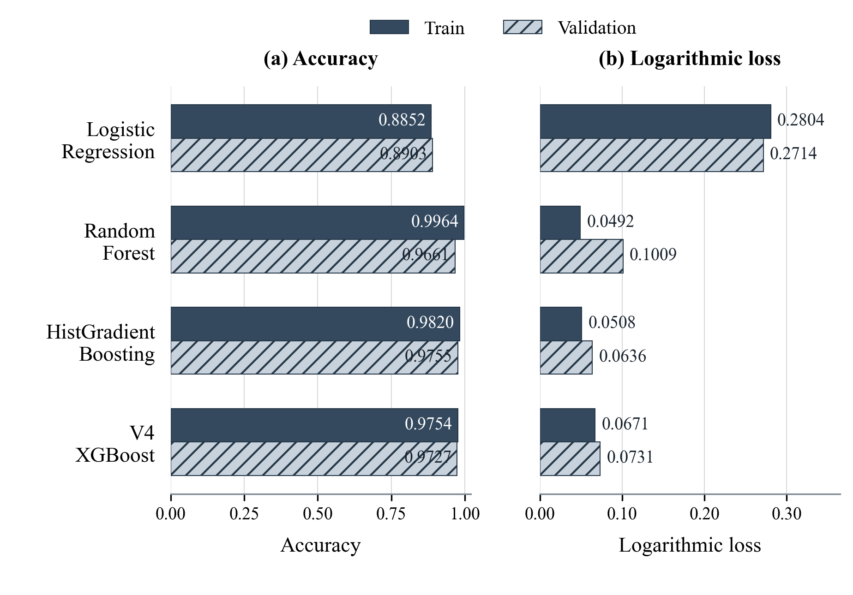
Figure 3.7: Recorded candidate training and validation accuracy and log loss
Note: Final recorded performance from the completed synthetic development runs; the bars do not represent an epoch-by-epoch learning curve.

3.7.3 Controlled Diagnostics and Feature-Service Verification
Bounded diagnostic fits tested dominance, missingness shortcuts, seed sensitivity and shuffled labels. The later forty-four-field comparison remained exploratory and did not replace frozen V4. Chapter 4 reports sparse support and weak S2/S4 recall.
The exploratory comparison appended four structuring descriptors to the original forty: recent similar-amount value, offset baseline similar-amount count, distinct recent in-band amounts and offset baseline in-band count. Baseline counts use the twenty-eight days immediately preceding the recent seven-day window; S2/S4 additions require thirty-five-day age/four activities. Unsupported baselines emit -1, valid zeros remain zero; encoding yields forty-six columns.
For the four experimental additions, the recent cluster and band sets used the exact definitions in Section 3.4.4. Their calculation rules were:
$$x_{41} = V(C_{R})$$
$$x_{42} = n(C_{B})$$
$$x_{43} = |\{a(e) : e ∈ R_{7d}, 700000 ≤ a(e) ≤ 1050000\}|$$
$$x_{44} = n(\{e ∈ B_{7d} : 700000 ≤ a(e) ≤ 1050000\})$$
The comparison examined S2/S4 detections alongside overall metrics and losses elsewhere. Reused Validation showed mixed gains, including unchanged S4 and weaker A4; Chapter 4 presents the numerical results. Neither experimental artifact replaced the frozen forty-field XGBoost pipeline.
Because repeated Validation inspection informed the feature hypothesis, these exploratory results cannot estimate untouched-population performance. No reserved population supplied accepted V4 evidence and no predecessor metrics were borrowed. Independent authorised evaluation remains outstanding.
Feature checks cover order/types, missing semantics, equal-time ordering, current-event inclusion, future exclusion, wallet/agent isolation and cold start. Model checks cover hash, forty-two columns, probability and threshold boundaries. Invalid inputs fail explicitly; these are service checks rather than statistical accuracy estimates.

3.7.4 Functional Integration and Evidence Boundaries
Disposable tests cover atomicity, request idempotency, post-commit success/failure, revision changes and audited recovery. Permission checks cover routes, conversations, attachments and staff events; browser checks cover history and receipts. Chapter 4 reports scope without claiming every device/load was tested.
Table 3.14 defines conditions and expected behaviour; Chapter 4 records outcomes. Extraction, inference and routes are tested separately, so fixtures do not substitute for real transport, payments or statistical evaluation. The frozen extractor includes thirty independent hand-computed fixture cases with parametrisation.
Table 3.14: Feature, model and application verification protocol
Purpose | Input or condition | Expected behaviour | Evidence and result location
Contract and order | Exactly forty frozen named fields; extra, missing or reordered field; unknown type | Accept only exact semantic order; transform to forty-two columns; reject malformed inputs explicitly | Frozen specification, preprocessing and service fixtures; actual counts in Chapter 4
Causal keys and current inclusion | Equal UTC timestamps with smaller/larger IDs; permitted current role once; duplicate ID | Smaller keys prior; larger keys excluded; current only once in declared descriptors; duplicates rejected | Independent key, duplicate and hand-computed feature fixtures
Future and metadata independence | Append later events; alter private labels/provenance; rename IDs consistently | Earlier vector unchanged; metadata rejected/excluded; identity renaming preserves calculations | Future-append and private-field fixtures; Chapter 4 results
Wallet and partition isolation | Unrelated wallet/partition activity; received versus sent transfers | No cross-partition state; correct subject and directed counterparties; incoming not structuring activity | Partition audit and role-specific extraction fixtures
Agent aggregation | Assisted transfer, cash-in/out, repeated serviced wallets and absent agent | One service per explicit wallet; no cash amounts for transfers; correct distinct/top-two sets | Independent agent primitives and directed cash fixtures
Boundaries and cold start | Exact lower/upper window edges; no history; just sufficient coverage/support; empty median bins | Open-lower recent/baseline rules; explicit UTC-day exception; declared zero/sentinel semantics | Age, support, calendar, seven-day and twenty-four-hour fixtures
Numerical safety | Valid negative residual -1; NaN; invalid type, nonpositive amount or infinity | Preserve legitimate negative residual; impute only permitted missing fields; reject schema errors/infinities | Residual, timestamp/schema and preprocessing fixtures
Artifact and probability | Expected hash and class order; transformed dimensions; probabilities below/at/above 0.50 | Trusted model loads; class-one probability used; inclusive boundary; errors never become normal predictions | Frozen manifest and model-service tests; Chapter 4 actual scope
Financial commit and retry | Valid/invalid payment; repeated request ID; failed commit; inference failure or revised source | Atomic balances/payment/captures; no second payment; explicit error and audited nonfinancial retry | Disposable integration and post-commit coordinator tests; no new live financial write
Risk and investigation | AI-positive, rule-only positive, normal/no finding, pending V4; existing case notes | Separate findings; precise review triggers; preserve case identity/status; authorised notes/outcome | Primary/retry policy and role-route fixtures; Chapter 4
Access and communication | Customer, compliance, administrator and unrelated user; receipts, history and attachments | Permitted routes/threads only; customer-admin blocked; stored receipts before private events | Permission, messaging and browser fixtures; actual scope in Chapter 4
Real-time objective | Committed event; two independently running instances and authenticated browser clients | Start timer at commit publication, stop at visible second-browser state; target under five seconds; unauthorised event count zero | Isolated Redis evidence is reported separately; full panel timing remains unmeasured
A proportion-based real-time test must count all valid scheduled updates and separately record authorised second-browser updates arriving within five seconds, plus misses, duplicates and delays. Instance/client IDs and timestamps identify observations. The isolated Redis measurement in Chapter 4 excludes browser/network latency and cannot fulfil this end-to-end criterion.
Outstanding evidence comprises accepted independent V4 evaluation, representative operational labels and measured panel timings for Table 3.11. Pending analyses and missing observations remain explicitly unverified.
Nonfinancial policy tests check numeric weighting, review requirements, primary/retry consistency, rule-only errors and alert metadata preservation. They establish implementation behaviour, without live payments, detection-effectiveness estimates or panel timing claims.

3.8 Summary
This chapter specified the environment, architecture, canonical boundary, synthetic populations, causal forty-field preprocessing and frozen model construction. Five algorithms define observable timed workflows with separate AI, rule and human evidence. Chapter 4 presents the recorded results, interfaces, limitations and objective verification.

